**SQL Joins**

There are four basic types of SQL joins: inner, left, right, and full. The easiest and most intuitive way to explain the difference between these four types is by using a Venn diagram, which shows all possible logical relations between data sets.

Let’s say we have two sets of data in our relational database: table A and table B, with some sort of relation specified by primary and foreign keys. The result of joining these tables together can be visually represented by the following diagram:

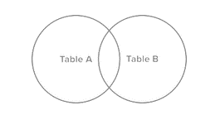

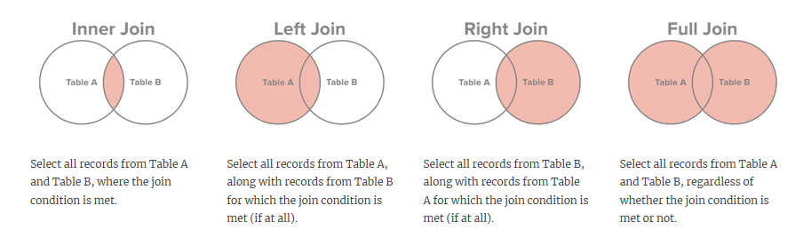

**INNER JOIN**

SELECT column_name(s)  
FROM table1  
INNER JOIN table2 ON table1.column_name = table2.column_name;

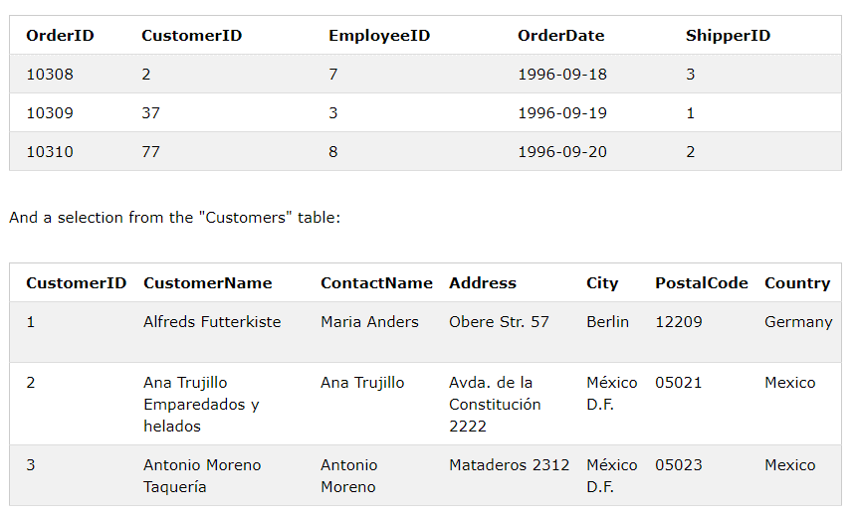

SELECT Orders.OrderID, Customers.CustomerName

FROM Orders

INNER JOIN Customers ON Orders.CustomerID = Customers.CustomerID;

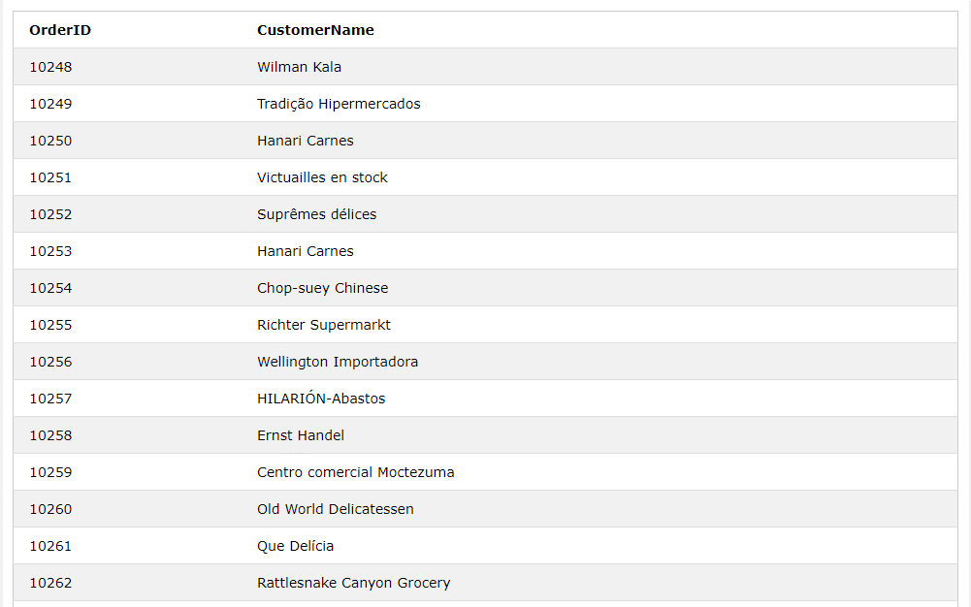

**Join over two tables**

SELECT Orders.OrderID, Customers.CustomerName, Shippers.ShipperName  
FROM ((Orders  
INNER JOIN Customers ON Orders.CustomerID = Customers.CustomerID)  
INNER JOIN Shippers ON Orders.ShipperID = Shippers.ShipperID);

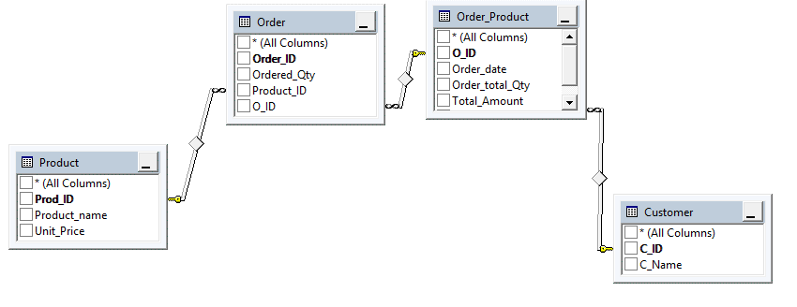

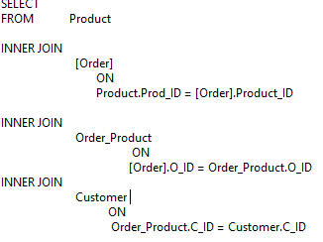

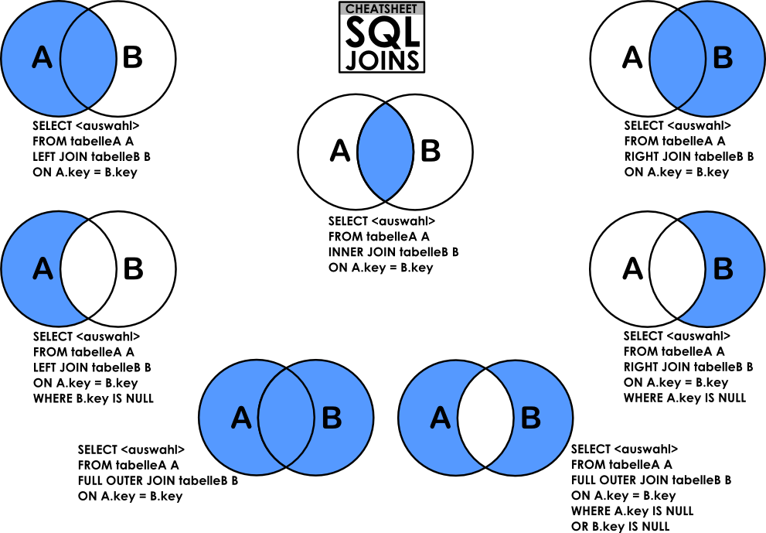

## **SQL LEFT JOIN Keyword**

The LEFT JOIN keyword returns all records from the left table (table1), and the matched records from the right table (table2). The result is NULL from the right side, if there is no match.

SELECT column_name(s)  
FROM table1  
LEFT JOIN table2 ON table1.column_name = table2.column_name;

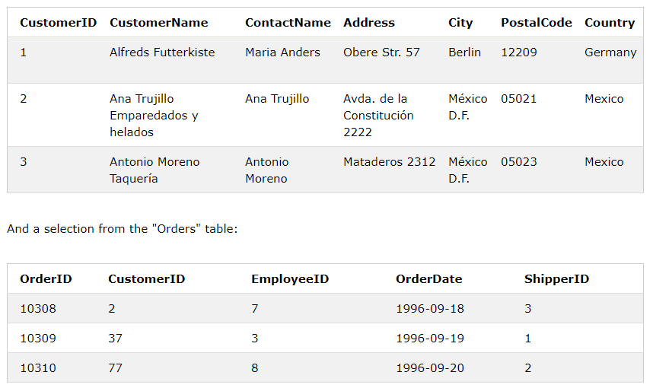

SELECT Customers.CustomerName, Orders.OrderID  
FROM Customers  
LEFT JOIN Orders ON Customers.CustomerID = Orders.CustomerID;

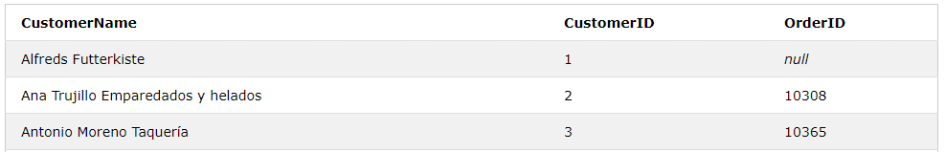

**SQL RIGHT JOIN Keyword**

The RIGHT JOIN keyword returns all records from the right table (table2), and the matched records from the left table (table1). The result is NULL from the left side, when there is no match.

SELECT column_name(s)  
FROM table1  
RIGHT JOIN table2 ON table1.column_name = table2.column_name;

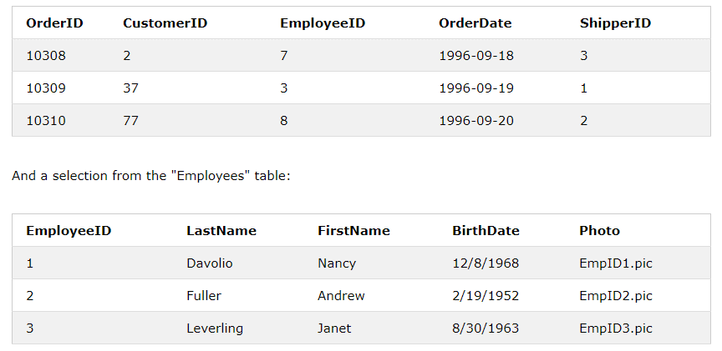

SELECT Orders.OrderID, Employees.LastName, Employees.FirstName  
FROM Orders  
RIGHT JOIN Employees ON Orders.EmployeeID = Employees.EmployeeID  
ORDER BY Orders.OrderID;

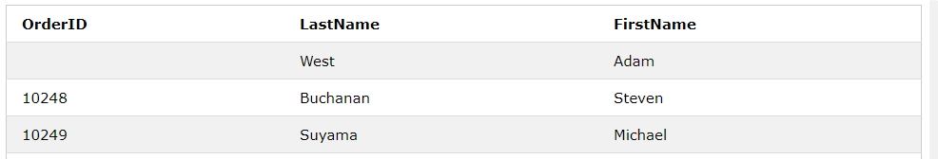

**Example**

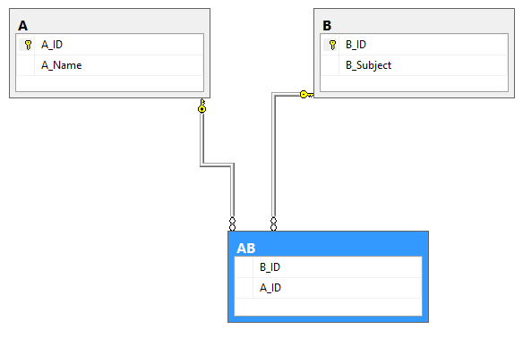

**A**

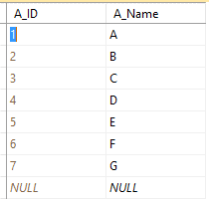

**B**

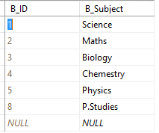

**AB**

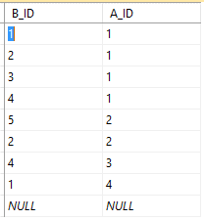

**Inner join Query**

SELECT A.A_Name,B.B_Subject

FROM AB

INNER JOIN

A

ON

A.A_ID = AB.A_ID

INNER JOIN

B

ON

AB.B_ID = B.B_ID

**Retrieved Result**

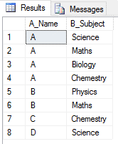

**Inner join Query**

SELECT A.A_Name,B.B_Subject

FROM A

INNER JOIN

AB

ON

A.A_ID = AB.A_ID

INNER JOIN

B

ON

AB.B_ID = B.B_ID

**Retrieved Result**

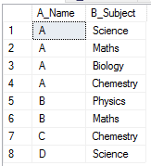

**Inner join Query**

SELECT A.A_Name,B.B_Subject

FROM B

INNER JOIN

AB

ON

AB.B_ID = B.B_ID

INNER JOIN

A

ON

AB.A_ID = A.A_ID

**Retrieved Result**



**Left join Query**

SELECT A.A_Name,AB.B_ID

FROM A Left JOIN

AB ON AB.A_ID = A.A_ID

**Retrieved Result**

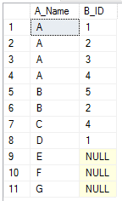

**Left join with inner join Query**

SELECT A.A_Name,AB.B_ID

FROM A

Left JOIN

AB

ON

AB.A_ID = A.A_ID

Inner join

B ON B.B_ID = AB.B_ID

**Retrieved Result**

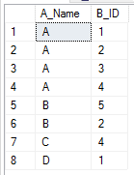

**Inner join with left join Query**

SELECT A.A_Name,AB.B_ID

FROM A

inner JOIN

AB

ON

AB.A_ID = A.A_ID

left join

B ON B.B_ID = AB.B_ID

**Retrieved Result**

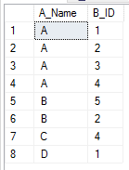

**Left join with left join Query**

SELECT A.A_Name,AB.B_ID

FROM A

Left JOIN

AB

ON

AB.A_ID = A.A_ID

left join

B

ON

B.B_ID = AB.B_ID

**Retrieved Result**

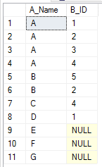

**Inner join with right join**

SELECT A.A_Name,AB.B_ID

FROM A

inner JOIN

AB

ON

AB.A_ID = A.A_ID

right join

B ON B.B_ID = AB.B_ID

**Retrieved Result**

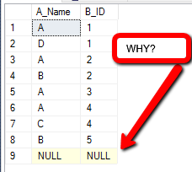

**Right join with inner join**

SELECT A.A_Name,AB.B_ID

FROM A

right JOIN

AB

ON

AB.A_ID = A.A_ID

inner join

B

ON

B.B_ID = AB.B_ID

**Retrieved Result**

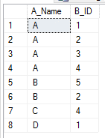

**Right join with right join query**

SELECT A.A_Name,AB.B_ID,B_Subject

FROM A

right JOIN

AB

ON

AB.A_ID = A.A_ID

right join

B ON B.B_ID = AB.B_ID

**Retrieved Result**

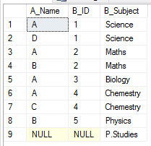

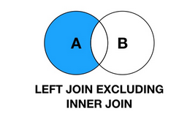

SELECT A.A_Name,AB.B_ID

FROM A

Left JOIN

AB

ON

AB.A_ID = A.A_ID

where AB.A_ID IS NULL

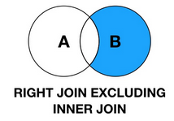

SELECT AB.A_ID,B.B_Subject

FROM AB Right JOIN

B ON AB.B_ID = B.B_ID

where AB.A_ID IS NULL

